Europe: Geography |  | 1-4
Europe | Europe is a continent in the northern hemisphere. On the west is the Atlantic Ocean. To the south is the Mediterranean Sea. The eastern boundary is formed by the Ural Mountains in Russia.
Mediterranean  Sea | An eastern part of the Atlantic Ocean. The Mediterranean Sea touches the southern countries of Europe and the northern countries of Africa.
Rhine  River | A major river in central Europe flowing south to north. The Rhine starts in the south and flows north through Germany to the Atlantic Ocean.
Danube  River | A river in central Europe flowing west to east. The Danube begins in Germany and flows east to the Black Sea.
English Channel | A narrow part of the Atlantic Ocean between England and France. The English Channel is 20 miles across at its narrowest point.
European Plain | A huge, flat, area of farmland that stretches across northern Europe.  It reaches from the Pyrenees to the Ural Mountains, over 2000 miles.
Alps Mountains | A chain of very high, steep mountains in Europe. Many peaks are covered by ice and snow. The highest peak is Mont Blanc in France, at 15,700 feet.
Pyrenees Mountains | A chain of mountains between France and Spain. Some peaks are high and icy, but there are many small towns in the valleys of the Pyrenees.
Ural Mountains | A long chain of gentle mountains in Russia. The Ural Mountains stretch 2000 miles north-south and form the border between Europe and Asia.
Iberian Peninsula | A square-shaped landform in southwest Europe. It is bordered by the Atlantic Ocean to the west and the Mediterranean Sea to the east. Spain and Portugal make up the Iberian Peninsula.
Scandinavian Peninsula | A long loopy landform in northernmost Europe. It extends north past the Arctic Circle. Norway and Sweden make up the Scandinavian Peninsula.
United Kingdom | An island nation north of mainland Europe. It includes England, Scotland, Wales, and Northern Ireland. Be careful! England, English, Britain, British, Great Britain, and United Kingdom are used at different times.
France | A pentagon-shaped nation at the western edge of Europe. France includes the Pyrenees and Alps mountains, the European Plain, and the city Paris.
Belgium | A small country bordered by France, Germany, and the English Channel.
Germany | A large country at the center of Europe. Germany includes the Alps, the European Plain, the Rhine and Danube Rivers.
Russia | A huge county in northeast Europe and Asia. Russia has the largest land in the world. Western Russia is part of Europe; the Ural Mountains divide Russia; eastern Asian Russia is mostly cold, empty land.
Poland | Poland is a square-shaped country in eastern Europe, east of Germany.
Ukraine | Ukraine is in southwest Europe on the Black Sea, west of Russia.
Spain | Spain is a country between the Mediterranean Sea and the Atlantic Ocean.
Italy | Italy is a boot-shaped peninsula in the Mediterranean Sea.

Europe: Geography | N  D C |  |  | 1-4
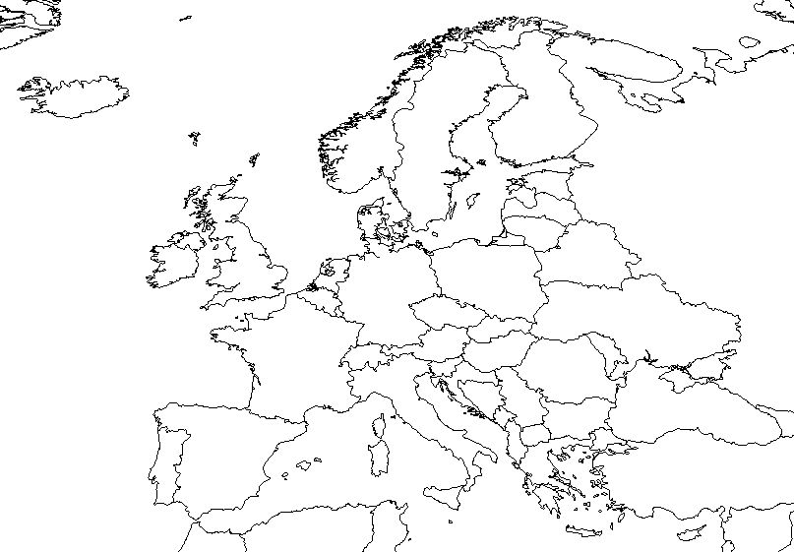 |  | 1. Find the English Channel. Label it, then label the UK and France.  2. Between the Atlantic Ocean and the Mediter-ranean Sea is the Iberian Peninsula. Label all three.  3. Making an arc  across Europe are:  Spain, France, Germany, Poland, Ukraine, Russia. Label them.  4. Label the Scandinavian Peninsula, Norway and Sweden.
5. Label Italy. Label Belgium, east of France, west of Germany. (The other small country, north of Belgium, is The Netherlands, or Holland. The Rhine River flows through Germany and meets the sea at Rotterdam in The Netherlands.) Does the Rhine flow north or south? _______
 |  |  | Label the three major mountain ranges and the two major rivers. The Danube and the Rhine do not meet. What do you suggest to improve water transportation in Europe?
Circle the correct answer. Which are higher, the Alps or the Pyrenees?
Which is longer, the Danube or the Rhine? Which is bigger, Russia or the US?
Which is smaller, Poland or Ukraine? Which borders the English Channel, Spain or France?
Which borders Poland, Germany or Russia? Which divide France and Spain, Ural or Pyrenees?

