

Appreciation
Appreciating the wonder and beauty of the world and its people



Commitment
Being committed to their learning, persevering and showing self-discipline and responsibility



Confidence
Feeling confident in their ability as learners, having the courage to take risks, applying what they have learned and making appropriate decisions and choices

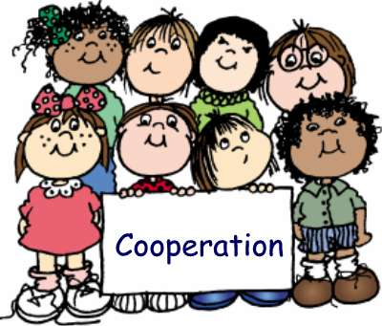

Co-operation
Co-operating, collaborating and leading or following as the situation demands


Creativity
Being creative and imaginative in their thinking and in their approach to problems and dilemmas


Curiosity
Being curious about the nature of learning and the world, its people and cultures

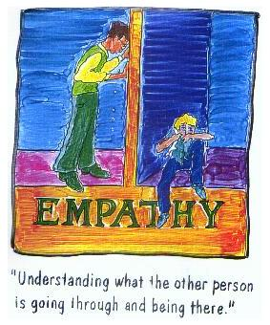

Empathy
Imaginatively projecting themselves into another’s situation, in order to understand his/her thoughts, reasons and emotions


Enthusiasm
Enjoying learning


Independence
Thinking and acting independently, making their own judgements based on reasoned principles and being able to defend their judgements



Integrity
Having integrity and a firm sense of fairness and honesty


Respect
Respecting themselves, others and the world around them


Tolerance
Feeling sensitivity towards differences and diversity in the world and being responsive to the needs of others

