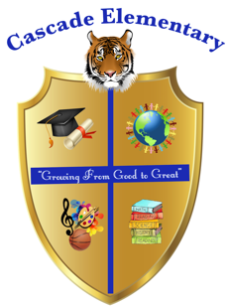

Cascade Elementary Website
Weekly Grade Level News Blast

Week of: Monday, March 23, 2020

Grade Level:

Standards of the Week:
Career Awareness
To expose students to the numerous opportunities available in order for them to their reach their career goal

Additional Information for Parents and Students :
Career Awareness encourages elementary students to explore their interests and passions as an extension of their academic program and in the process better understand themselves, their community, and the world. Please click the link below to enter a world of careers with a multitude of exciting and meaningful activities.

Virginia Career View
This virtual website is AWESOME for all grade levels. This website has a variety of activities, specific to each grade level.
https://vacareerview.org/k5/ (K-5)

