  November | 2023
Sunday | Monday | Tuesday | Wednesday | Thursday | Friday | Saturday
 |  |  | 1 | 2 | 3 | 4
 |  |  |  |  | Free Food Pantry  11 am- 1 pm  Ram Recognition  1:15 pm | Discovery Program  9 am – 12:30 pm  The Black Child Book Fair  10 am- 3 pm
5 | 6 | 7 | 8 | 9 | 10 | 11
 |  | Virtual Learning Day  Election Day | Picture Day  The Center for Puppetry Arts In-House Field Trip-  1st grade |  | TOTY Program | Discovery Program  9 am – 12:30 pm  Veterans Day
12 | 13 | 14 | 15 | 16 | 17 | 18
World Kindness Day  Diwali |  |  |  | Ramsgiving Luncheon  RAMP University: Math Edition @ 9 am & 5 pm
19 | 20 | 21 | 22 | 23 | 24 | 25
 |  |  |  | Thanksgiving Break
26 | 27 | 28 | 29 | 30
 | MAP Testing Begins | Giving Tuesday |  | RAMP University: Finance @ 5 pm
Events | Native American Heritage Month  First declared a month of recognition in 1990 by President George H.W. Bush, this November heritage month celebrates Indigenous Peoples in the United States. Discover their rich culture, traditions, dance, music, crafts, and way of life. Take time to learn about the contributions of Native people this November. | Attendance Matters Every day!  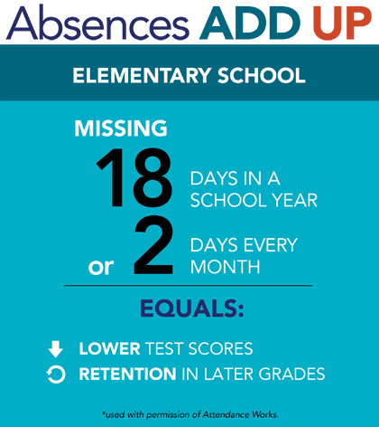 | What is RAMP University?  RAMP University partners with community stakeholders, teachers, parents, and other organizations to offer workshops.  - Will equip families with new knowledge, and resources.  - Provides families with a fun and interactive way to learn the very latest in a vast array of current topics related to raising happy, healthy, successful students.  - Workshops are led by trained professionals and educators.  - Families can increase a child's academic and social success through their involvement with schools and communities.  - Student confidence, attitudes, and academic achievement across all subject areas increase with parental involvement!  We encourage you to become involved with RAMP University!

