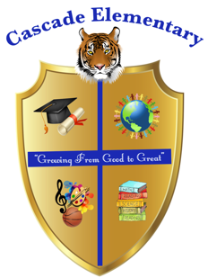

Cascade Elementary Website
Weekly Grade Level News Blast

Week of: Monday, April 20, 2020

Grade Level: 4th

Standards of the Week:

Reading (ELAGSE4RI1) Refer to details and examples in a text when explaining
what the text says explicitly and when drawing inferences from the text.

Math (MGSE4.MD.5) Recognize angles as geometric shapes that are formed
wherever two rays share a common endpoint, and understand concepts of angle measurement.

Social Studies (SS4H6) Analyze the effects of Reconstruction on American life

Science (S4P2) Obtain, evaluate, and communicate information about how sound is produced and changed and how sound and/or light can be used to communicate.

Additional Information for Parents and Students:
Make sure students sign on to Dreambox, MyOn and MyLexia every day. Weekly assignments can be found in the Google Classroom under WeatherWise look for the date for that week. The link will be on find the link for zoom on google classroom every day.

