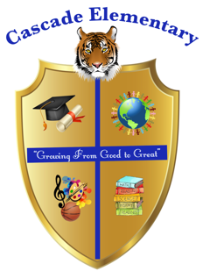

Cascade Elementary Website
Weekly Grade Level News Blast

Week of: Monday, May 4, 2020

Grade Level: 4th

Standards of the Week:

Reading (ELAGSE4RI3) Explain events, procedures, ideas, or concepts in a historical, scientific, or technical text, including what happened and why, based on specific information in the text.

Math (.MGSE4.MD.7) SWBAT recognize angle measure as additive IOT solve addition and subtraction problems to find unknown angles on a diagram in real world and mathematical problems.

.Social Studies (SS4H6) Analyze the effects of Reconstruction on American life.

Science (S4P2) Obtain, evaluate, and communicate information about how sound is produced and changed and how sound and/or light can be used to communicate.

Additional Information for Parents and Students:
Make sure students sign on to Dreambox, MyOn and MyLexia every day. Weekly assignments can be found in the Google Classroom under WeatherWise look for the date for that week. The link will be on find the link for zoom on google classroom every day.

