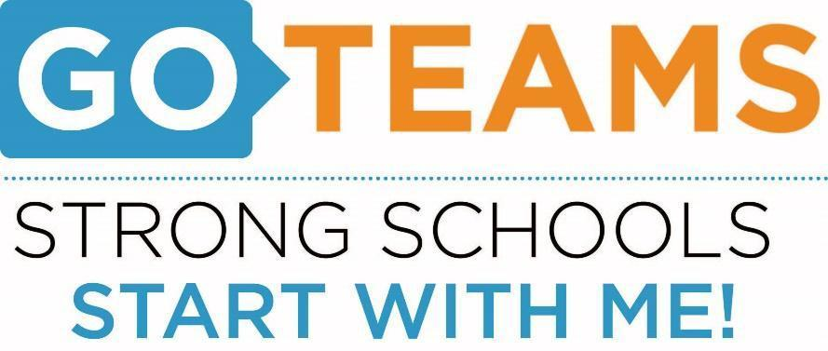



|  |  |  |  |
| --- | --- | --- | --- |
| **School Name** | **Date** | **Time** | **Location** |
| Cleveland Avenue Elementary | March 31, 2017 | 7:30 am | Main Conference Room |

# Action Items:

# Complete GO Team Training

* Austerity

**The meeting agenda will include the following topics:**

* Austerity
* Go Team Mandatory Trainings

# Discussion Items:

# Information Items:

# 

Date of Notice: 3/28/2017

Name of Person Preparing Notice: Tamika Harris

Telephone number of person preparing Notice: x 8420