**Data Review, Fall 2020**

Financial Condition:

|  |  |  |  |
| --- | --- | --- | --- |
| FY21 Projection | 951 |  |  |
| Day 25 Enrollment | 846 |  |  |
| Difference | -105 |  |  |
| Leveling Amount Due | $465,921 |  |  |
| Hold Harmless | $408,968 |  |  |
| Partial Restoration of Reserve Funds | $65,926 |  |  |
| NET Adjustment | **$8,973** |  |  |
|  |  |  |  |
|  |  |  |  |

Georgia Milestones Review:

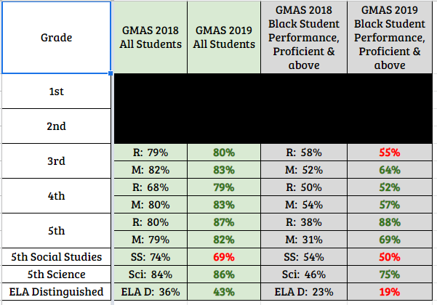

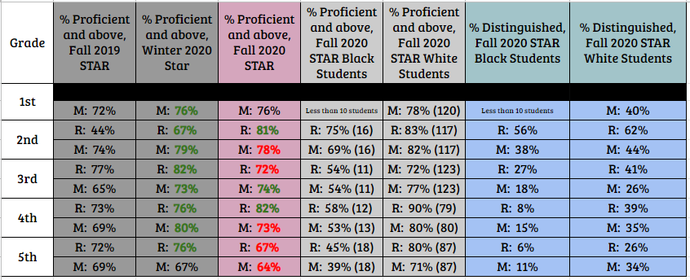STAR Summary:

STAR Cohort:

