**Sarah Smith Elementary**

**Date: January 25, 2024**

**Time: 3:15**

**Location: Sarah Smith IC Media Center**

1. **Call to order:** 3:20
2. **Roll Call**

|  |  |  |
| --- | --- | --- |
| **Role** | **Name** *(or Vacant)* | **Present or Absent** |
| **Principal** | **Dwight Hutson** | **Present** |
| **Parent/Guardian** | **Cimona Hinton Dirickson** | **Present** |
| **Parent/Guardian** | **Mary Posada** | **Present** |
| **Parent/Guardian** | **Ann Mintman** | **Present** |
| **Instructional Staff** | **Bejay Osby (Acting Chair)** | **Present** |
| **Instructional Staff** | **Jennifer Chestnut** | **Present** |
| **Instructional Staff** | **Karla Lamar** | **Present** |
| **Community Member** | **Laquisha Smith** | **Present** |
| **Community Member** | **Ben Miller** | **Absent** |
| **Swing Seat** | **Andrea Almario** | **Present** |
|  |  |  |

**Guests Present:**

**Quorum Established:** Yes

1. **Action Items** 
   1. **Approval of Agenda:** Motion made by: Ann, Seconded by: Cimona

Members Approving: All

Members Opposing: None

Members Abstaining: None

**Motion** Passes

* 1. **Approval of Previous Minutes:** *No amendments to previous Minutes*

Motion made by: Cimona Seconded by: Laquisha

Members Approving: All

Members Opposing: none

Members Abstaining: none

**Motion** passes

* 1. **Strategic Plan Review and Update:** Motion made by: Ann ; Seconded by: Cimona
  2. Members Approving: All

Members Opposing: None

Members Abstaining: None

**Motion** Passes

* 1. **Ranking of Strategic Plan Priorities:** Members discussed changing the ranking of the strategic priorities. Perhaps moving #3-5 up above #2 since those pertained directly to student data and achievement. Karla Lamar and Jennifer Chestnutt explained the importance of keeping #2 at its current location. Referring to the importance we place on the IB curriculum as the overarching umbrella that contains all reading, writing and math development. Since that idea is a core to our school it needs to remain as a top priority.

**There were no changes made to the strategic plan priorities.**

* 1. Motion made by: Cimona; Seconded by: Karla

Members Approving: All

Members Opposing: None

Members Abstaining: None

**Motion** Passes

1. **Discussion Items** 
   1. **Measures of Academic Progress (MAP)/ Georgia Milestones (GMAS) Data Presented** 
      1. **GMAS testing** (3rd-5th Grade) over time. Mr. Hutson shared this GMAS chart compiling data from past years, to show trends over time along with goals for our strategic plan. The years 2019/2020 & 2020/2021 were not included due to covid.

* + 1. **MAP data discussion**: According to Math MAP data, 58% of students made average to high average growth from fall to winter this year.
    2. Mr. Hutson explained that meeting with teachers, evaluating their students’ scores and identifying areas where they can meet the students’ needs, has contributed to continued progress.
    3. In Reading MAP data, 56% of Sarah Smith students show average to high growth from fall to winter this year. This time last year, the school average was at 50% showing this growth; therefore, we are continuing to show improvement.
  1. **Review Budget Development Process** 
     1. Review and Update meeting calendar: The GO Team voted to add February 8th as the GO Team Budget Feedback Meeting before the school staffing conference on February 28th.
  2. **Budget Allocation Presentation**:
     1. Mr. Hutson detailed the FY25 school priorities:
        1. Increase math and science scores, especially in third through fifth grade.
        2. Implement IB with fidelity.
        3. Increase reading scores and writing of third through fifth grade students.
        4. Maximize the intervention block daily and utilize data to meet the individual needs of students.
     2. Jennifer discussed adding scores and success criteria to have more specific and measurable outcomes for areas of growth.
     3. The total budget projected for FY 2024-2025 is $11,214,145. Mr. Hutson walked the Go Team through the budget allocations seen in the chart below. Student Success Funding (SSF) is the districts funding formula that allocates funds to schools equitably, based on their student attributes. Our total SSF funds amounted to $6,993,094. With additional earnings of $4,221,051 detailed below.
     4. 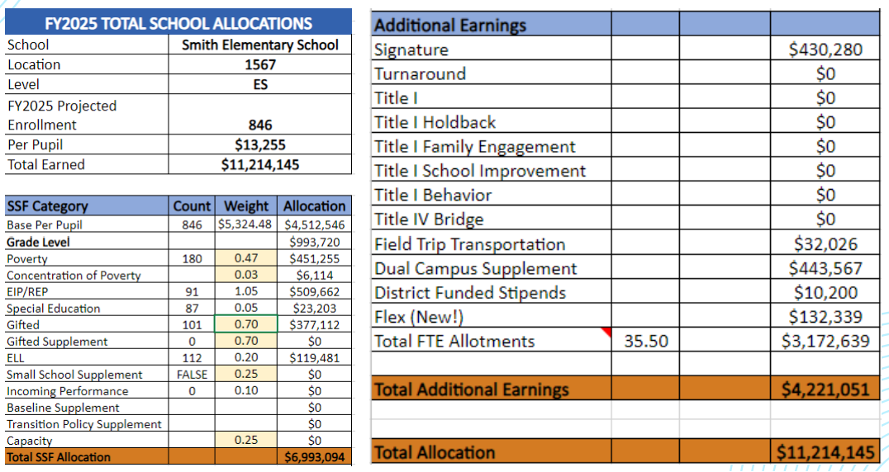
     5. Atlanta Public Schools does not provide additional funds to support DLI.
     6. Mr. Hutson will be creating a budget using this budget allocation aligned with the strategic plan. This will be reviewed at the next meeting.

1. **Information Items** 
   1. **Principal’s Report** 
      1. There is an accreditation meeting coming up, the administration team is compiling information for the accreditation team.
      2. The IB recertification is coming up as well. Staff, teachers, and parents will be interviewed in the process, along with binders of information put together by the leadership team.
      3. Funds from the federal CARES Act: Mr. Hutson and the administrative team are identifying areas to spend final CARES funds before they expire. Mr. Hutson identified expanding the media centers with technology and resources to allow students the opportunity to be collaborative and engage in partner work. Examples include modular furniture and white boards and three collaborative screens. Additional resources will be books in the top five native languages of the student population to add to the libraries, professional development books for teachers, materials and supplies to use in classrooms.
      4. The Read-A-Thon is underway; students have read over 311,000 minutes, adding to the yearly goal of a million minutes.
2. **Announcements** 
   1. All Go Team members must complete their budget training in ELIS.
   2. Bejay shared a concern raised to him from the 3rd, 4th, and 5th grade teachers regarding the timing of International Travelers (IT) week. IT week occurs prior to Georgia Milestone testing, and the teachers felt that losing 4 days of instruction would negatively impact test scores. Third through fifth grade teachers have a high preference that IT week take place after GMAS in May for next school year (2024-2025).
3. **Public Comment**
   1. Elizabeth Zielinski, a parent to 2nd and 4th grade students, shared a concern about low growth in MAP math scores over the years. Her children came in with high math scores, and over the years, the scores have consistently dropped. She inquired what can be done, beyond online tools, to grow competency in math for high achieving students. She shared that Heards Ferry (Fulton County - Sandy Springs) teaches Advanced Math to all students who qualify. They allow parents to opt in for this enrichment if their child is on the cusp. She would like Sarah Smith to offer Advanced Math to students who would benefit from it. She also thinks that IT week should be in May.
   2. Greg and Cate Hearn are Kindergarten parents. They are concerned about high teacher turnover last year, resources to support new teachers, and recruitment and retention efforts to attract the best teachers. As families are weighing enrollment options, what can SRS do to tell the story of our school’s success to our community and reduce unknowns within the current parent community moving forward. How can SRS increase communication of our school’s goals, outcomes, and success. He inquired if there are plans to support 1st grade with paraprofessionals as has been done in kindergarten.
4. **Adjournment**

Motion made by: Ann Seconded by: Andrea

Members Approving: All

Members Opposing: none

Members Abstaining: none

**Motion** Passes

**ADJOURNED AT** 4:28

-----------------------------------------------------------------------------------------------------------------------------

**Minutes Taken By:** Ann Mintman

**Position:** Secretary

**Date Approved:** February 8, 2024