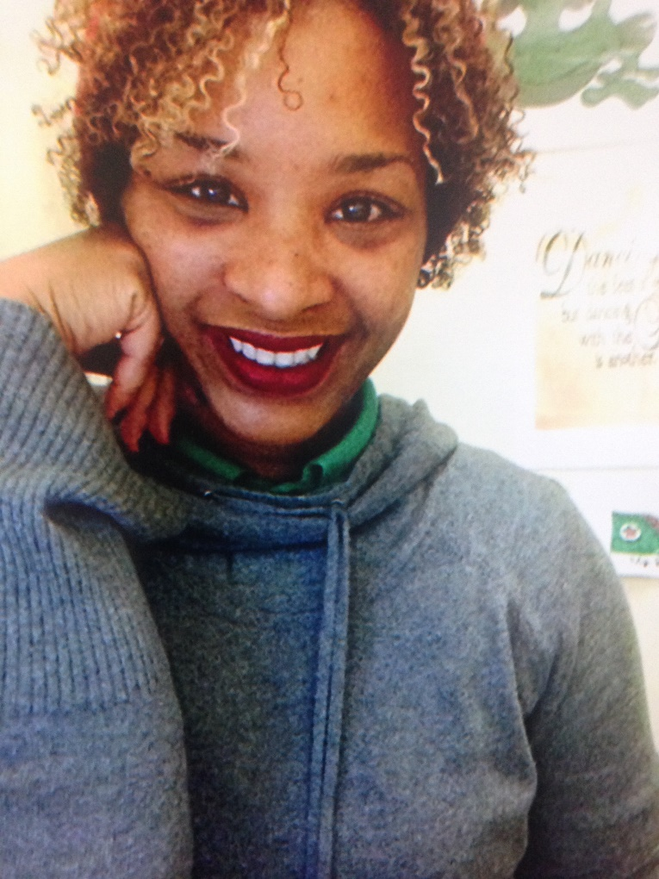
Hello World! My name is Tiffany Rudd-Claudius. I am a native of Mississippi. I moved to Georgia in 2013. I have three sisters, one brother, six nephews, and two nieces. My husband’s name is Jeff. I love my family very much. I graduated from Delta State University with a Bachelor of Science degree in Exercise Science. I also earned a Master of Art in Education degree in Curriculum and Instruction. For the past 12 years, I have been teaching dance full-time and part-time. This is my second year teaching First Grade.

