Burgess-Peterson Academy
2016-2017 PROCEDURAL GUIDE

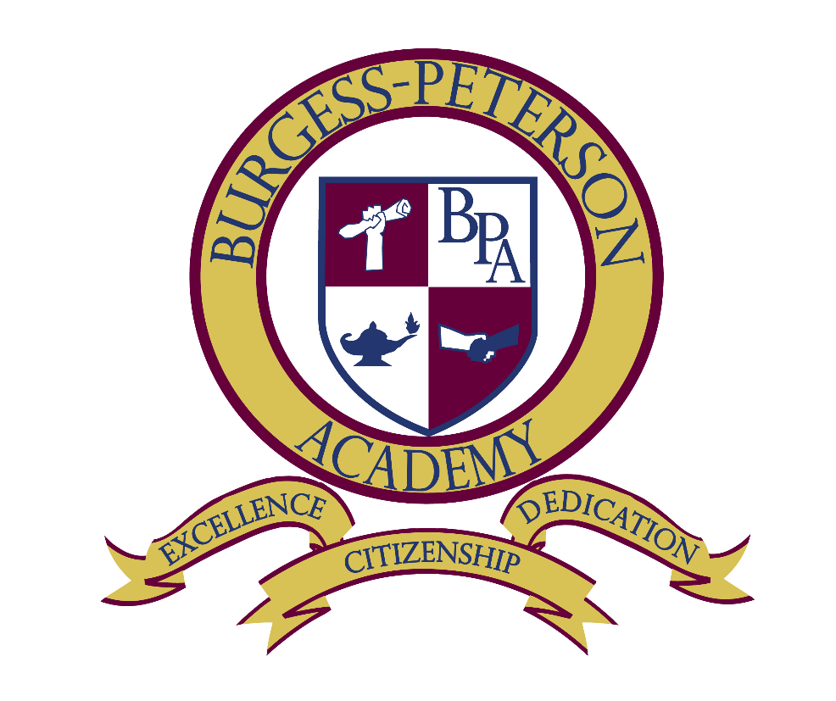
Our vision for BPA: “The neighborhood school of choice and a viable, desirable, traditional public school option for the child of any family in East Atlanta.”

David A. White, Principal
dwhite@atlantapublicschools.us
Sabrina R. Hayes, Assistant Principal
srhayes@atlantapublicschools.us
Melanie Searcy, Instructional Coach
msearcy@atlantapublicschools.us
Tracy King-Holmes, IB Coordinator
tdking-holmes@atlantapublicschools.us
Main Office Phone - 404-802-3400
WELCOME
Welcome to the 2016-2017 school year at Burgess-Peterson Academy. We strive to educate the whole child at BPA and we are a community of learners. We believe that communication and collaboration are essential to our success and we invite you to partner with us for the growth of our students and our school. Let’s team up for success!

This procedural guide is designed to facilitate our success as we partner to provide a well-structured, organized, safe, healthy, productive, and engaging learning environment for all students. Please carefully read the guide so that you and your child are familiar with our procedures and expectations. We also encourage you to read the APS Student Handbook for district expectations, procedures, and policies.

COMMUNICATION & INFORMATION AT BURGESS-PETERSON ACADEMY

“BPA Courier” -
This maroon folder will go home every Thursday, school-wide. It may include information from the classroom, the school, the PTA, and the district. Please take the time to review everything inside. This is an attempt to streamline and simplify communication to all our families.

BURGESS-PETERSON ACADEMY WEBSITE
Our communications ambassador and PTA work to keep our website up to date. Please visit burgesspeterson.com. Our district website also has a wealth of information and updates, www.atlanta.k12.ga.us. Burgess-Peterson Academy parents are always welcome to use computers in our media center or in the BPA Parent Center just across the hall from the Media Center. Join David’s REMIND 101 by going to http://remind.com/join/bpaco .

BURGESS-PETERSON ACADEMY PARENT CENTER
Our Title I Parent Liaison, Luana Slaughter, manages our Parent Center, which is located across the hall from our media center in Room C11. Our Parent Center houses resources that include academic support, a uniform and school supply closet, and computers for parent use. Please visit our Parent Center. You may reach Luana by emailing her at lkslaughter@atlantapublicschools.us or by calling her at 404-802-3404.

SCHOOL-TO-HOME COMMUNICATIONS
In addition to the BPA Courier, we will use personal calls and school-wide “robo-calls” to contact parents from time to time. It is very important that we always have a way to contact you. Please keep your phone number and emergency contact numbers updated with the school at all times. You may update your information in the Infinite Campus Parent Portal. You can also send changes in writing to our office clerk, Ms. Greer via call or email. 404-802-3400 qgreer@atlantapublicschools.us It is unsafe for you to be unreachable during the school day.

BURGESS-PETERSON ACADEMY PTA
Please join our PTA! Membership dues are $5.00 per member. Sign up at Open House, at a PTA meeting or learn more by emailing president@burgesspeterson.com .

BURGESS-PETERSON ACADEMY “GoTeam”
This school governance board works with our principal to plan for improving BPA’s outcomes for all our students. The membership of this inaugural board is comprised of three parents, three staff members, two community members and one “swing” seat. Our principal is a non-voting member of the GoTeam.
Other members include:
Parents: Jeanne Forre, Lewis Cartee, Geraldine Thomas
Staff Members: Melanie Searcy, Melanie Sithole, Tracy King-Holmes
Community Members: Marc Takacs, Sue Ellen Woertzel
Swing Seat; Aretta Baumgartner

BURGESS-PETERSON ACADEMY TOURS
Have a neighbor or a friend who wants to learn more about BPA? Encourage them to come take a tour!
Email tour@burgesspeterson.com to learn more and schedule a guided tour.

ARRIVAL & DISMISSAL AT BURGESS-PETERSON ACADEMY

BELL SCHEDULE & SCHOOL HOURS
Our doors open to receive students at 7:30 a.m., which is 30 minutes prior to the beginning of the instructional day. School begins promptly at 8:00. Bus riders will be received upon arrival. Families with special situations who require additional time in the morning may register for early drop off beginning at 7:10 each morning in the gymnasium. These families MUST register with Ms. Poehlein or Ms.Stokes. vpoehlein@atlantapublicschools.us or gstokes@atlantapublicschools.us

School opens for walkers/car riders | Start of instructional day | End of instructional day | Walkers/car riders must be picked up by
7:30 a.m. | 8:00 a.m. | 2:30 p.m. | 2:45 p.m.

TARDY ARRIVALS
Students should be seated in the classrooms and ready to learn by 8:00 a.m. Students who arrive after 8:05 a.m. are late and will be coded as tardy on our Infinite Campus attendance report. Tardies beyond the fifth tardy will be referred to the school social worker. Students who are tardy MUST stop by the office to receive a tardy slip to class. Students who enter class after 8:05 a.m. without a tardy slip will be sent back to the office.

Students who are tardy miss important routines, morning announcements, academic work, and classroom procedures that set the tone for the learning day. Punctuality is an important habit for college and careers that we can model and instill in our students today. Please make every effort to get our students to school on time.

To minimize interruptions after 8:00 a.m., we ask that tardy students proceed from the office to their classroom independently. Parents can walk their students to class until 8:00 a.m. However, teachers are not available to conference with you during this time because they are receiving students and completing daily routines and procedures. Please schedule a conference with your child’s teacher by calling the main office or emailing your teacher directly. Our teachers are eager to work with you and they want to give the conference the focused attention it deserves.

EARLY DISMISSALS
If you need an early dismissal for your student, please report to the main office and sign your student out on the early dismissal log. Office personnel will call the classroom and your student will be sent to the office with his/her belongings. Parents may not go to the classroom to get the student.

Early dismissals after 2:10 p.m. are not allowed. Just as the opening of our instructional day is important, so is our closing. Teachers review content, assign homework, and bring instructional closure at this time. Our dismissal procedures are designed for the safety and security of all students and dismissal requests after 2:10 p.m. disrupt our school-wide processes and increase the likelihood that student safety and well-being may be compromised.

It is the responsibility of the parent to notify the office in writing each year and as needed if there are specific persons who are not permitted to interact with or pick up their child. If custody papers exist, the school is legally bound to follow the decree contained in the most recent version of such documents.

TRANSPORTATION CHANGES
If your child’s usual method of transportation home is going to change, please provide written notification to the teacher or to the main office.
We cannot take changes over the phone and we cannot make changes after 2:00 p.m.

ABSENCES FROM SCHOOL
Regular attendance is very closely tied to student success in school. One of our goals this year is for no student to miss more than 5 days of school. Unless they are sick, we want our students to be present and on time every day at Burgess-Peterson Academy. Every hour of every day counts! Please avoid scheduling appointments, trips, and events when school is in session. In the event of an absence, please provide a written excuse upon the student’s return. Absences without documentation are coded as unexcused. Excessive absences will result in a referral to our school social worker.

WE DRESS FOR SUCCESS AT BURGESS-PETERSON ACADEMY!

SCHOOL UNIFORMS
Burgess-Peterson Academy is a uniform school and we ask that all Burgess-Peterson Academy students support our uniform policy Monday, Tuesday, Wednesday and Thursday. We allow students to show their individuality on Fridays which is a non-uniform day.
TOPS
- Maroon, Navy Blue or White
- The shirt should be polo-style with a collar or a button down with a collar
BOTTOMS
- Khaki or Navy Blue
- Pants, Skirts, Jumpers/Dresses
- Denim should not be worn except on Fridays

APPROPRIATE ATTIRE FOR ADULTS
In support of our learning environment, we ask that all adults wear appropriate attire in the building. We are all role models for our students and we set the example for them at all times. No sleepwear or pajamas, revealing attire, or clothing with profane language, please.

VISITORS & VOLUNTEERS AT BURGESS-PETERSON ACADEMY

We welcome you to visit and volunteer in our school. We know that students thrive when their parents are engaged in their educational experience. Please follow our procedures to support our success.

SIGN IN and OBTAIN A VISITOR STICKER
There is a new computer station at the front desk at which you should enter your name so you can have a brightly colored visitor sticker. This will let anyone in the building know you have checked in and are cleared to be in the hallways/classrooms.

VISITING THE CLASSROOM
We must maximize instructional time at Burgess-Peterson Academy to ensure our students’ growth and success. We ask that everyone support our goals by avoiding interruptions to instructional time.

7:30 – 8:00 a.m. – Parents can walk students to the café or gym at 7:30 a.m. or to the classroom beginning at 7:35 a.m.
8:00 a.m. – Our instructional day begins
8:05 a.m. or later – Students who are tardy can be escorted to their classroom by our staff or go independently.

CLASSROOM OBSERVATIONS
Parents are welcome to observe in their child’s classroom. As an observer, you may not talk to the teacher or other students in the classroom. Our teachers are happy to conference with you at a scheduled time but they cannot do so during instructional time. As always, parents must sign in in the main office first.

CLASSROOM VOLUNTEERING
We are happy to welcome you as a volunteer and we want to make your volunteer time meaningful. We do not accept “walk-in” volunteers because we can’t interrupt instruction to determine the teacher’s volunteer needs. Please call or email your child’s teacher or the office to schedule your volunteer time at least one day in advance. Our teachers are happy to have your assistance and they want to make the most of your time.

VOLUNTEER REQUIREMENTS
Per APS policy, all volunteers must be approved prior to service. Ms. Slaughter, our Parent Liaison, is the contact for volunteering. All volunteers must complete the APS Volunteer Release Form and school personnel will search the Georgia and federal sex offender registry websites prior to approving the volunteer. Once cleared to volunteer, a visitor’s pass from the main office is required.

BPA is a TITLE I School
Because more than 40% of our students come from families who experience some degree of financial hardship our school receives federal funding from the Title I program. We primarily use these funds to employ an Instructional Coach who works with our teachers to plan lessons and assessments. Additionally, we employ a Parent Liaison with these dollars. She works to strengthen our community relationships and make parents feel welcome and plugged in here at BPA.

LUNCH at BPA
Our school is now designated as a CEP School. This stands for Community Eligibility Program and means that all students at our school are eligible to receive free breakfast and lunch every day. No need to carry cash and no need for families to apply for meal pay assistance. Every child eats free every day.
This will be true through the 2017/2018 school year.

You are welcome to join your child for lunch in the cafeteria at his/her scheduled lunch time. A visitor’s pass from the main office is required. If you would like to purchase a school lunch, the cost is $4.00 for adults. You can bring your child a lunch of your choosing but you cannot bring or share any snacks or food items of any kind for other students. WE ARE A “NUT FREE” SCHOOL! Please, NO Peanuts or peanut products or other tree nut products at any time.

Need a CARPOOL NUMBER?
Many of our students get to and from school via their family car. Any one driving their student to school or picking them up needs a carpool number. Mr. Jarrett is our Carpool King and he manages the carpool system. Please email him at rojarrett@atlanta.k12.ga.us to sign up for a new number or to get an additional hang tag for your rear view mirror. Carpool pick up vehicles can line up along the front curb beginning at 2:00. We begin dismissal at 2:30. Please remain in your vehicle at all times and have your carpool number displayed by hanging it from your rear view mirror with the number facing AWAY from you so we can see it from the curb.

MONITORING YOUR CHILD’S PROGRESS AT BURGESS-PETERSON ACADEMY

PARENT-TEACHER CONFERENCES are REQUIRED after Quarter 1 and Quarter 3
We encourage you to communicate regularly with your child’s teacher. We want to partner with you for your child’s growth and success. You can email your teacher or call the office to schedule a conference. Our teachers cannot talk with you during instructional time or when they are on duty supervising students. A scheduled conference by phone or in-person allows the teacher to review your child’s work samples, tests, grades, academic strengths, and areas for growth. Parent-teacher communication is a powerful tool and all BPA teachers are required to host parent conferences at the end of the first and third quarters.

INFINITE CAMPUS PARENT PORTAL
The Infinite Campus Parent Portal allows you to monitor your child’s grades and attendance online. Our teachers update their grades in the portal every week. To access the portal, you must get your personalized credentials from Ms. Greer, our Office Clerk. (qgreer@atlantapublicschools.us) Parents can monitor their children in grades K – 12 with one login!
The portal can be accessed by computer and/or parents can download the portal app on their phone. The web address is https://ic.apsk12.org/portal.
If at any time you need computer access, you are welcome to use our media center.
AFTER-SCHOOL OPPORTUNITIES AT BURGESS-PETERSON ACADEMY

WEDNESDAY AFTERNOON TUTORIAL
For students requiring additional support, our teachers provide tutorial on Wednesday afternoons from 2:30–3:30 p.m. Wednesday tutoring occurs at BPA beginning the first Wednesday in September and ending the final Wednesday in April. Permission slips for tutorial will be sent home by the teacher as needed throughout the year. Transportation is not provided. Students must depart within 15 minutes of the end of tutorial, no later than 3:45 p.m.

Global Tech AFTER-SCHOOL PROGRAM
Our after-school program offers homework assistance, free snack/dinner, and an impressive variety of enrichment activities. Please contact Bernardo Baker for further information. bernardo.baker@globaltechacademy.com or call 404-919-9948 or visit www.globaltechacademy.com.

CLUBS & ORGANIZATIONS
Our teachers may sponsor additional after school clubs or activities on a volunteer basis. These offerings may change from year to year as teachers’ time and personal obligations permit. Clubs, organizations, and special events will be announced via BPA Courier as they become available.

REQUESTS TO PROHIBIT VISITATION
It is the responsibility of the parent to notify the office in writing each year and as needed if there are specific persons who are not permitted to interact with or pick up their child.

HEALTH & WELLNESS AT BURGESS-PETERSON ACADEMY
Burgess-Peterson Academy has received local, state, and national recognition for our fitness, health, and wellness initiatives. We promote active lifestyles and healthy choices for our students. Please support our goals by making healthy choices too! In an effort to grow our school’s commitment to healthier lifestyles, we continue our partnership with the East Atlanta Village Farmers’ Market and the EAV RunFest and STRUT Parade!

FOOD CHOICES
- We are a NUT-FREE school. Please do not send food items containing nuts.
- For birthday recognitions and/or celebrations of learning, consider healthy treats and goodies. Avoid sugary, high-fat, and processed items and choose healthy options instead.

PHYSICAL ACTIVITY
- Our students have regularly scheduled PE and recess throughout the week. We encourage our students to get active! Please send students in shoes that are appropriate and safe for physical activity. No flip flops, sandals, or slides, please. All classrooms are expected to have 20 minutes of recess daily. This is unstructured play time so students can get some exercise and socialize with friends.

MEDICATION & ILLNESS
- We want our students at school every day unless they are sick.
- We cannot administer medication at school without the APS Administration of Medication/Medical Procedures form completed by a doctor and filed at school. The form is available in the office or you may email Nurse Welborn at vlwelborn@atlantapublicschools.us for the form.
- Students cannot carry medication at any time. Teachers cannot hold medications for students at any time, unless pre-arranged through the office/school nurse. For example, when attending a field trip.
- If your child is sick, please contact your child’s healthcare provider for advice and healthcare instructions. Your child should stay at home until he/she can maintain a normal temperature (below 100 degrees Fahrenheit or 37.8 degrees Celsius) for a full 24 hours or more without taking fever- reducing medication. This will lessen the chances of returning to school too soon and becoming ill, or infecting other people.

CLASSROOM PLACEMENT / TEACHER REQUESTS
Mr. White does not allow specific teacher requests at any time. This may be a change from what you’ve experienced elsewhere or even at BPA in years past. It is critical to David that each teacher at BPA be equipped and ready to teach any child at BPA. Teacher teams at BPA participate in weekly collaborative lesson planning with our Instructional Coach and IB program coordinator in an effort to ensure continuity and consistency of experience among students on grade level teams. Parents are, however, encouraged to give Principal White and his team input about what sort of learning environment works well for their child. Letters inviting this input are sent out each spring to the families who have updated their registration/enrollment information on time. Please watch for this process each school year in March and/or April.

In very unusual circumstances, Mr. White will consider a parent’s request to change a homeroom placement. Such requests will be heard by a team of administrators and teachers and a determination will be shared with the requestor in writing within five school days. No such requests will be received prior to Friday, August 12, 2016. Requests will be taken in writing only by emailing David directly at dwhite@atlantapublicschools.us .

We are excited about the new school year! Thanks for sharing your children with us!

