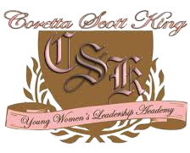

Coretta Scott King Young Women’s Leadership Academy
Title I Annual Parent Meeting
Thursday, September 25, 2025
9:30 am MS Teams
Parents Join Us!!!

- Learn more our Title I Program
- Title I Documents
- Parent and Family Engagement Program
- Testing Schedule
- and much more….


