Name:_________________________

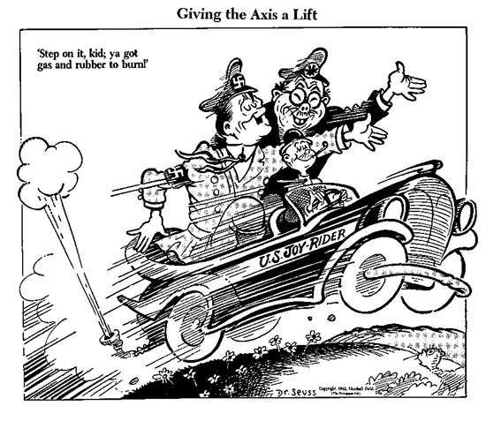
S.R. De Carlo 2010-2011 IB: Express Yourself: Historical Events Influence the Arts

The decades between the wars
World War I – World War II
STUDY GUIDE
Key Vocabulary

DictatorAssembly LineTrench Warfare

CapitalismStock Market

SocialismAlliance

European Map
Attached is a practice map of Europe – see me if you need additional copies. You can also practice by playing some of the Europe Geography games on www.sheppardsoftware.com.

History Influences Art
You will be shown one example of music, painting, and writing. You will be asked several questions about the artwork, such as the subject, what event in history inspired it, and other impressions you have of the artists’ works.

Key Concepts

- Why did the United States enter World War I?

- What new technology was being developed from 1920-1945?

- What would life have been like if you lost almost everything in the Stock Market Crash of 1929?

- How did Franklin Roosevelt try to help the economy? What government programs did he start?

- Why did Germany want to restore its power and conquer most of Europe? [Hint: How was Germany punished after WWI?]

- What is a Holocaust (also known as genocide and ethnic cleansing)?

- What is the significance of the following events…?

  - Pearl Harbor –

  - Iwo Jima –

  - V-E Day –

  - V-J Day –

  - Hiroshima / Nagasaki –

