**BURGESS-PETERSON ACADEMY**

**Date: Thursday, November 19th, 2020**

**Time: 6:00 PM**

**Location: ZOOM**

**Meeting ID: 374-345-1598 Password: daw**

1. **Call to order –** Ms King Ray
2. **Roll Call; Establish Quorum**

* Roll Call by T. Pendley, Secretary
* Present: D. White, M. King-Ray, T. Pendley, W. Angelety, A. Pam, D. Huggins, A. Dyson, T. Pace, M. Bland; D. Jacobi
* Not Present: (A. Dyson left approximately 6:45)

1. **Action Items** 
   1. **Approval of Agenda –** Motion to approveMs, Jackson, Second by Ms. Huggins.
   2. **Approval of Previous Minutes -** Motion to approve by Wendy, Seconded by Mike Bland
2. **Discussion/Information Items** 
   1. **Item 1**: Strategic Plan Priorities

* D. White used a slide deck to discuss BPA’s Strategic Plan Priorities.
* Behind our Strategic Plan is BPA’s Mission & Vision and goals to meet several measurable outcomes. We aim to be inclusive of any and all families within our community who live within our zone, as well as many other families outside of our zone. Our primary focus is on being the best service possible to the families in our zone as defined by the BOE.

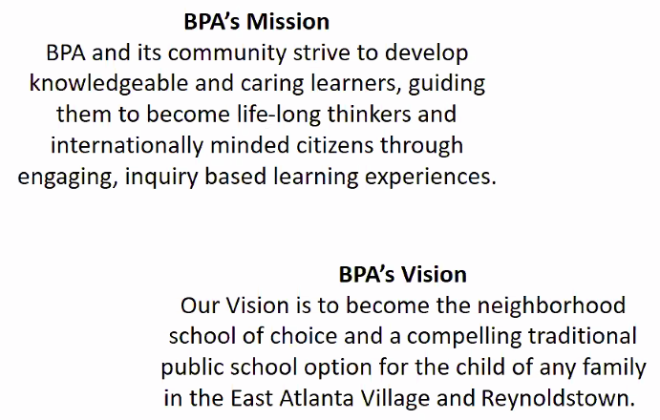

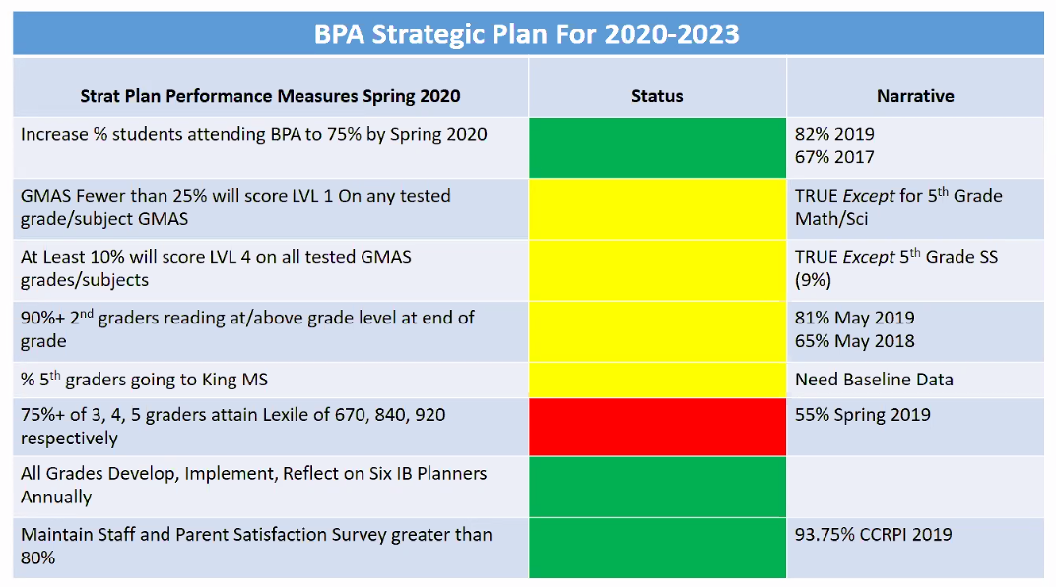

Measureable Goals:

1. Increase % of students attending BPA to 75%. **Goal Attained.**
2. We want fewer than 25% of students to score Level I on any tested subject GMAS. **In Progress**
3. We want to make sure that at least 10% of our students score in a Level IV. It’s important to grow the number of students in this top quadrant. **In Progress**
4. We want 90% or more of second graders reading at or above grade level by the end of the grade. **In Progress**
5. Increase the percentage of 5th graders going to King Middle School. **In Progress, but need baseline data.**
6. Increase the percentage of 3-5th graders attaining their target Lexiles to 75% or more. **Working towards goal, 55% as of Spring 2019.**

Priorities and Strategies:

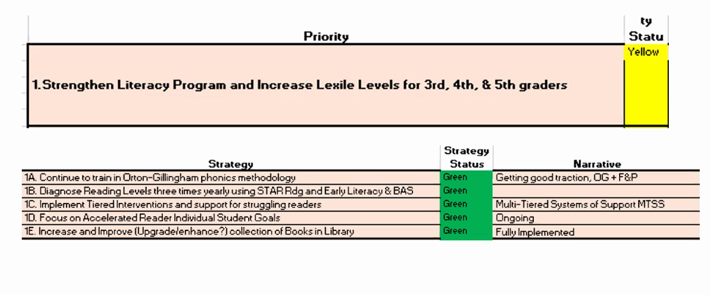

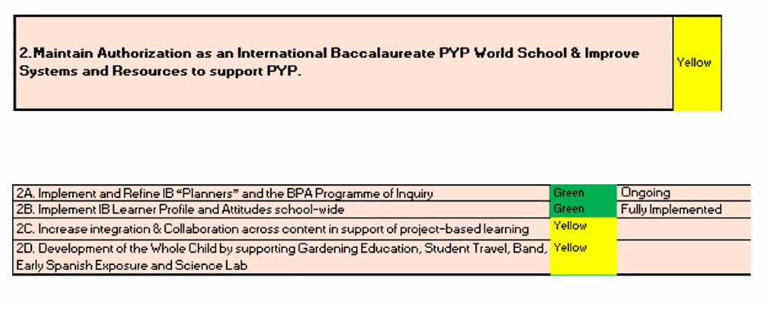

Continue working toward this goal. Great progress with IB Planners, Profile, and Attitudes.

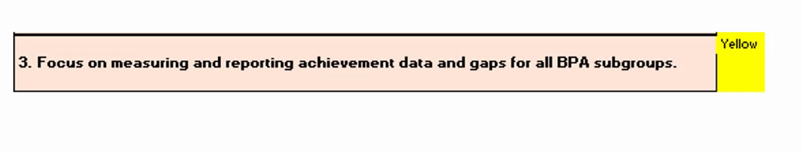

* Made no substantive progress on this goal yet.
* W. Angelety suggested looking at data from GOSA, the Governor’s Office of Student Achievement.

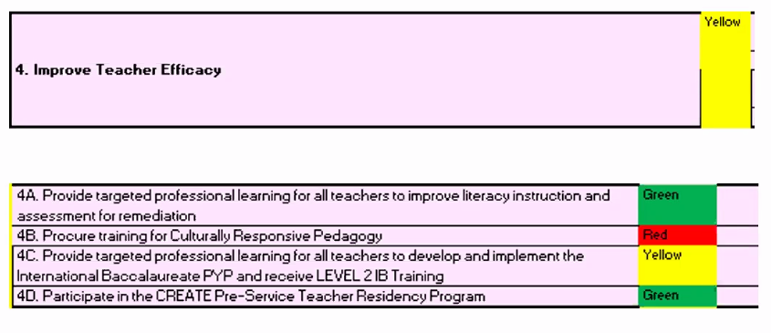

* Strategy 4b. was added in February/March. It has not happened yet due to the COVID leave from school. We have not yet added this in the virtual environment.

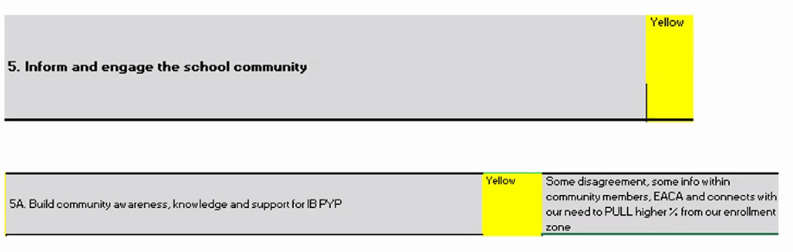

* This priority stays on here as a goal. We’ve done a lot with training, however we still do not think we do much work with telling our story beyond our school walls.
* D. White stated we’re capturing more school-aged students in the neighborhood, but we’re still not doing as much with marketing. However, it may not be as much of a need currently.
* T. Pace asked, “Has the district provided anything along the lines of professional development around helping teachers with assisting targeted subgroups?”
  + D. White is unaware of
  + We’ve distributed technology to students in these subgroups multiple times, and have addressed the lack of equity with hotspots. Other than trying to bridge the gap of access, we’ve not done any extra training with pedagogy.
  + M. King-Ray suggested reaching out to CREATE’s resources for equity groups, Critical Friendships.
  + T. Pendley added the work of iGroup and possibly using SRI’s book of Protocols to do some equity work.

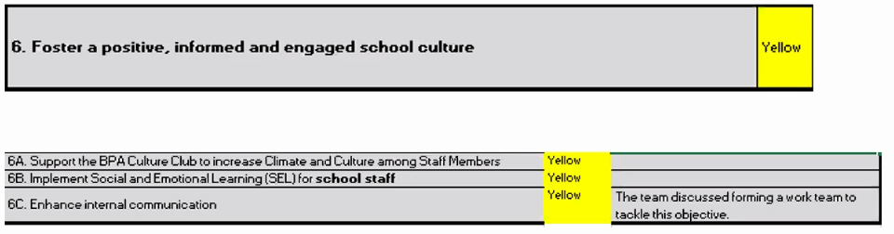

* On our most recent CCRPI, we were at 90%. But we will not turn that green because we want this to keep our attention.

Further Questions RE Action Item 1:

* M. Bland asked about the threshold for Lexile attainment. D. White communicated that 75% is the state threshold. Once we get close to 75% we will bump that up again, but it is not our current reality.
* M. Bland – As you incorporate methods, how does that translate into later grades as students move through? D. White responded that BPA teachers have done aggressive work and development in early literacy. This work takes multiple years. Unilaterally, at BPA strong reading instruction was not consistent across the board with regards to our beliefs as a school about how students learn to read. We’ve had tremendous growth, but it is a multi-year lift.
* T. Pace question – How much discretion does the school have with regards to band exposure and participation? Do we have a strategy for exposure? D. White responded, that this goal is within our second strategic priority, and that we’ve made progress by using additional funds to share a band teacher. This program has been in place for 3+ years. We would like to extend this offering to 3rd graders eventually.
* D. White – Last year, we made an effort to have band students from all 6 feeder schools sit in the stands on Cluster Night and play along with the older students. Helped to expose them and ideate further on what their experiences could be like.
  1. **Item 2**: Q3 “Return + Learn”
* M. King-Ray introduced Action Item 2, Return + Learn. This information is embargoed until the Superintendent releases it. This is not to be shared. However, D. Jacobi noted that these are open meetings and not secret (no non members are present).

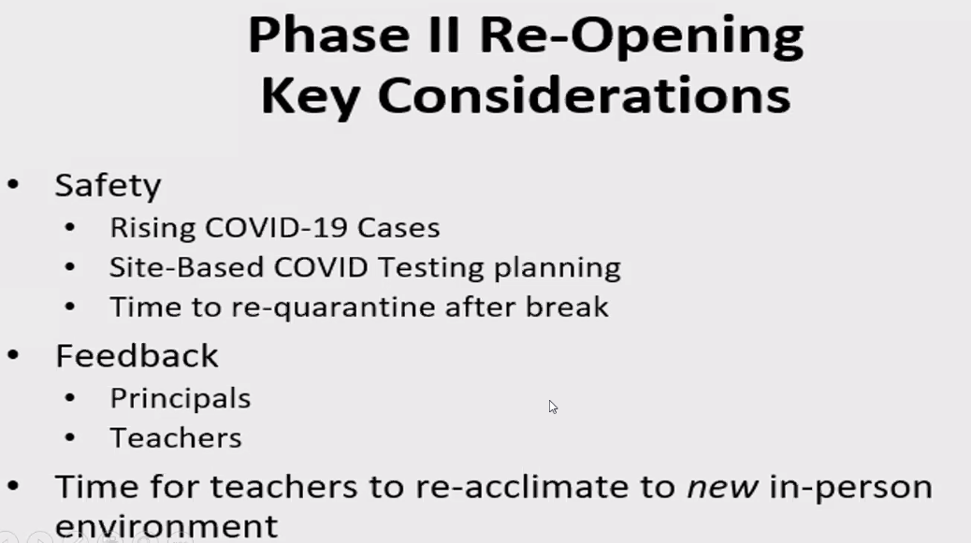

* We have several safety protocols in place.
* Declaration of Intent forms are on their way; informed parents this past Monday during Morning Meeting. This process will begin the Monday after Thanksgiving Break.
* Options have not changed – 3 choices: BPA physical, virtual, or Atlanta Virtual Academy. The only thing different here is the date – this has changed to the Monday after Thanksgiving.
* Asynchronous Wednesdays coming up!
* 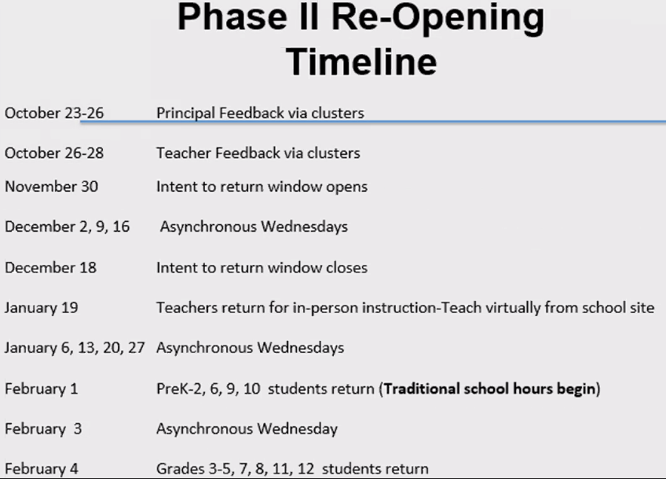MLK on January 18th. Teachers will return on January 19 to teach virtually. This is to help teachers to get back into the rhythm of coming into the building by coming to teach virtually.
* M. King-Ray asked if we know if the decision to return is still based on COVID data. D. White responded that yes, it will still be a critical determinant.
* Affirmed by Dr. Hildredth over Nursing Services is still 100/1,000.
* D. White shared the Teacher Schedules for Return to Learn for room set-up and reaclimation. There will be no students in the building in January.

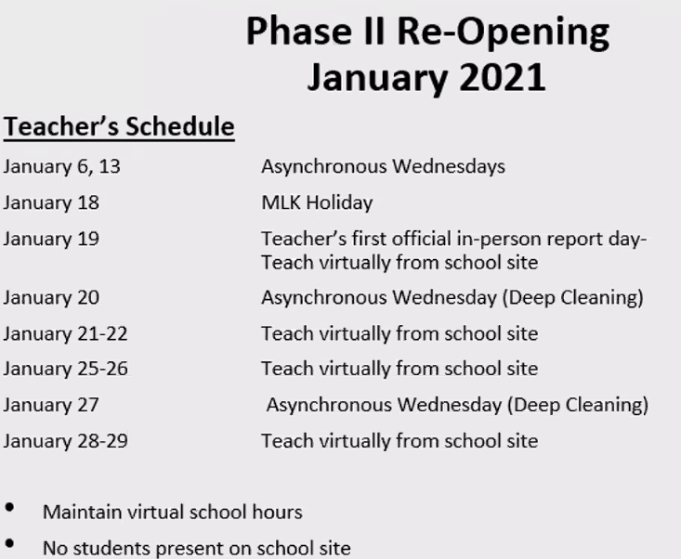

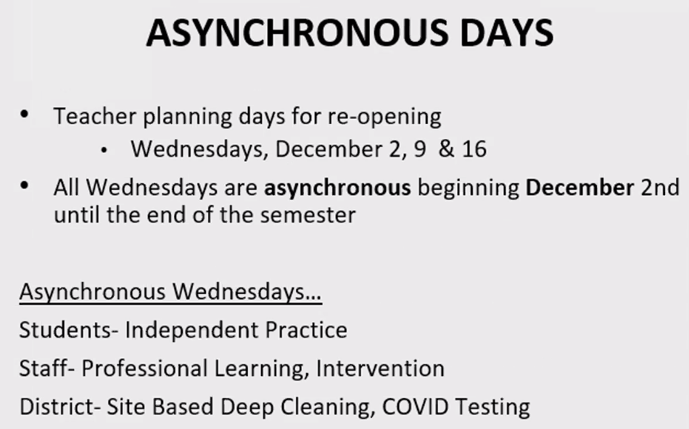

D. White addressed the Asynchronous Wednesdays. Some BPA teachers will utilize this day for small group instruction.

D. White will share this with BPA teachers by video tomorrow, Friday, November 20, 2020.

We’ll have the chance to practice protocols during TIP program: temperature, air purifiers, etc.

* 1. **Item 3:** BPA Targeted Intervention Program
* D. White updated team on the TIP plan. Students have desk shields, social distancing, etc. These students were chosen because of connectivity, attendance, issues. The plan requires us to give face to face and virtual interventions twice a week. We will pay for meals and provide transportation. We were going to use the funds for a summer program, however that program was eliminated due to COVID.

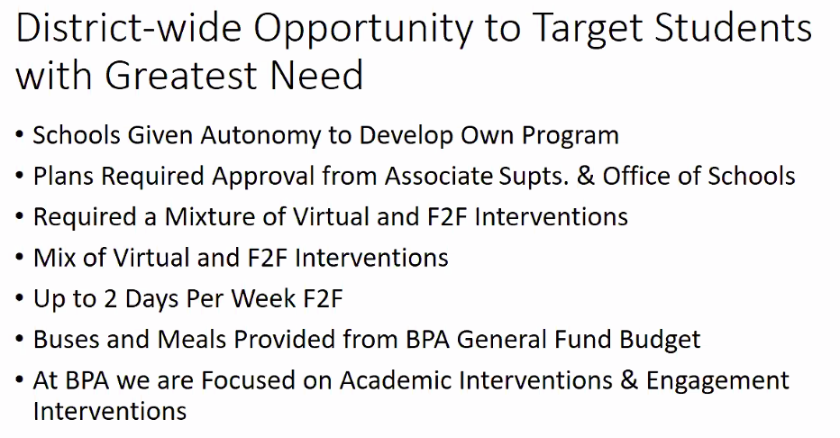

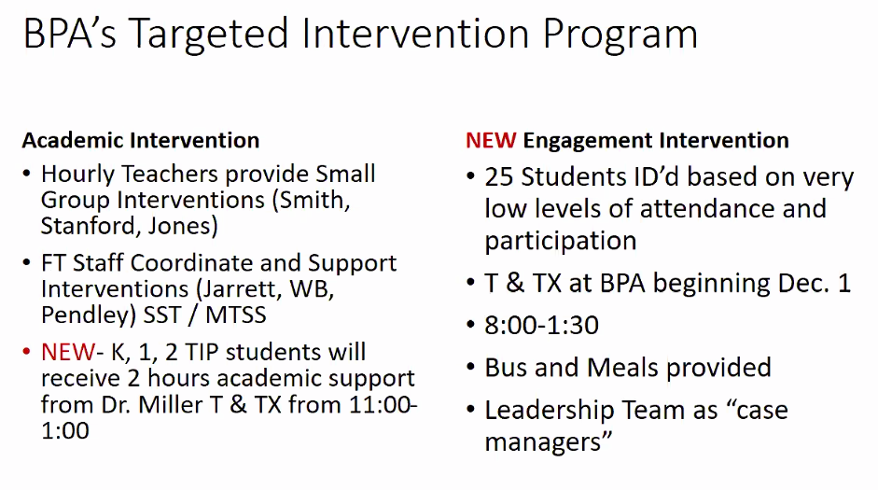

* D. White – Many academic interventions even before this targeted program. We employ three hourly teachers for intervention small group instruction.
* For the TIP program, they will receive a laptop that stays at school.
* Admin and leadership team will be case managers to make sure students connect with their Homeroom Teacher, support during meal times, recess, Google Classroom assignments.
* The younger students will have 1.5-2hours available for supplemental learning support. Older students will have a small break and then catch their 1:30pm bus.
* Our plan was to start this program during the current week, however a transportation mistake caused us to kick a week. Program will begin the Tuesday after Thanksgiving.
* We have to pay for transportation – 1 bus, twice a week, for four weeks. We decided to craft our intervention program during this time in order to not have to hire additional personnel and increase costs.
* So far, 23 of the 25 students’ families have responded yes.
* A. Pam: One bus for 25 students; concern about social distancing. D. White responded, the district was clear that we should have no expectation of social distancing on the bus per se. We will reload this bus from the back and try to skip seats, but there is no assurance that we’ll be able to keep kids 6 feet a part. Additionally, they will not have their temperature taken prior to loading the bus. This will happen at school. Students on the bus will however, be required to wear a mask and one will be provided if students do not have one.
* T. Pace asked – “Is it possible to hire a bus monitor?” D. White responded that because we are not using a lot of money for this program given the way we’re utilizing staff , that this is possible. D. White will explore this further.
  1. **Item 4:** Jackson Cluster Go Team Debrief
* Mr. White and T. Pace attended the Cluster Rep Meeting. T. Pace reported on the meeting.
* Task 1: Set meeting dates. For the Jackson Cluster, they set Meeting dates for Jan 26th, March 30th, April 27th.
* Task 2: Two reps for our cluster. One being T. Pace and Adam Dancer
* Discussed have cluster wide information shared regarding COVID health safety and involving health professionals; food distribution
* How do we bring our strategic plan in alignment with the cluster plan.
* Charter System Application – We’ll be a part of the process moving forward.
  1. **Item 5:** Additional Funds from APS
* M. King Ray introduced item. W. Angelety introduced this item and shares the discussion she had at a recent board meeting about how additional funds will be spent, including how it might trickle down to schools. It is approximately $2 additional dollars.
* D. White is not aware of these dollars. We hope it’s a yes!
* D. White wondered if this money is a part of the same bucket of money
* 7.5 million dollars for a one time stipend, and indicated that an additional amount may be pushed out to schools. This was made public during the board meeting.
* Presenter was Lisa Bracken.
* D. White to Wendy – do you have an idea if we are still concerned about the deficit in next year’s budget? People are not eating out or shopping as much – which links directly to the dollars we receive. W. Angelety believes that the next few years will be extremely difficult.
* D. White will reach out to L. Bracken to check in about these funds.
* D. Jacobi suggested that we look at loss/gain of number of students at various schools. Many went homeschool and private. Additional issue is “missing” kindergartners who didn’t come back. Hopefully, some will return as kindergartners and some will choose 1st grade. D. White - Any assessments will not determine placement.
* W. Angelety – We are under 50,000 students in APS as opposed to where we were before.

1. **Public Comment N/A**
2. **Announcements**

* January 7th at 6pm is the next GoTeam Meeting.
* Go Team officers should be on the look out for an email about go team training.

1. **Adjournment**

Request to adjourn by M. King Ray. Motion to adjourn by A. Pam, seconded by T. Pace. Meeting is adjourned.