**Coretta Scott King Young Women’s Leadership Academy**

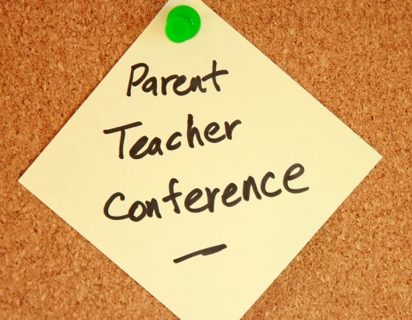

**The 2nd Tuesday of each month!**

**3:45pm-4:30pm**

**September 9, 2025 January 13, 2026**

**October 14, 2025 February 10, 2026**

**November 11, 2025 March 10, 2026**

**April 14, 2026**

**Parent/Teacher Conferences will be via zoom until further notice.**