What Is a  School-Parent Compact?  A School-Parent Compact is an agreement that parents, students, and teachers develop together. It explains how parents and teachers will work together to make sure all our students reach grade-level standards.  Effective compacts:  - Link to goals of the school improvement plan.  - Focus on GA. Standards of Excellence.  - Describe how teachers will help students develop those skills via high-quality instruction.  - Share strategies parents can use at home.  - Explain how teachers and parents will communicate about student achievement.  - Provide opportunities for parents to volunteer, and participate in the school.  Jointly Developed  The parents, staff, and teachers, and students for Coretta Scott King Young Women’s Leadership Academy collaboratively developed this School-Parent Compact for Achievement. Teachers suggested home learning strategies and supports, parents added ideas to make them more specific, and students told us what would help them learn. Our annual meeting is held at our End-of-the-year meeting in March 2025 to review the Compact and make changes based on student needs.  Parents are welcome to contribute comments at any time.  If you would like to participate in the  School-Parent Compact Input,  Please contact  Julia Jordan, Parent Liaison,  at 404-802-4901 |  |  | Parent University  Parental Engagement Series!  Join us for our monthly topics around the middle school and high school students starting in January 2026.  - Help support your child’s transition through Middle and High school.  - Learn about the Coretta Scott King Young Women’s Leadership goals for differentiation, identifying students’ individual learning strengths, needs, and interest.  - Farm-to-table initiative, Honey Bee learning center, CSK edible garden, AI Course, quail farming project, The chicken project, Mandarin Chinese World Language, AP 2-D Design Art, Chorus, Veterinary Science pathway, SAT/ACT classes for Middle and High School, and new this year-ASL course.  - Academic Recovery and targeted support for all students.  Communication About Student Learning  Coretta Scott King Young Women’s Leadership Academy is committed to frequent, two-way communication with families about student learning. Some of the ways you can expect us to reach you are:  - Weekly updates to the Parent Portal.  - Weekly robo-calls and remind texts to all families regarding learning objectives, important announcements, and upcoming events.  - Parent-Teacher conferences the 3rd Tuesday of the month.  - Principal’s Chat the last Thursday. |  |  | School-Family  Compact for  Achievement  2025-2026  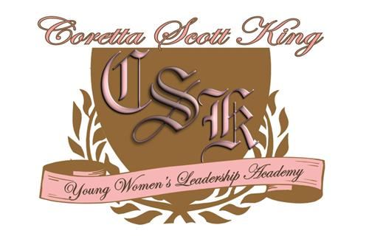  Coretta Scott King  Young Women’s  Leadership Academy  Eulonda Washington, Principal  Globally Conscious  STEAMINISTS      @cskywla  Coretta Scott King YWLA 6-12  (404) 802-4900  Revised: May 6, 2025

Our Goals for Student  Achievement  Early College/STEAM Initiatives:  Maintain a STEAM focus to support a Globally Conscious Steminist culture and climate. Maintain a 100% graduation rate for the 2025-2026 cohort.  All Grades:  Increase the GMAS proficiency rate to 40% for all EOC & EOG performance content areas.  Increase and maintain student average daily attendance to 95%. Increase the number of AP courses offerings by 20%.  Coretta Scott King Young Women’s Leadership Academy Schools Goals  Achievement Gap:  - Targeted Interventions for ALL Students in all core content  - Building and Consistently Maintaining a Student-Focused Culture  - Increased Teacher Effectiveness Through High Quality Coaching, PLCs, & Professional Development  - Build support courses in Master Schedule to address any learning loss evident due to virtual learning.  APS Mission -Through caring culture of equity, trust, and collaboration, every student will graduate ready for college, career, and life.  APS Vision- A high performing school district where students love to learn, educators inspire, families engage, and the community trust the system. |  |  | In the Classroom  The teachers will focus on social emotional learning, trauma resilience, culture of learning, essential content, academic ownership, demonstration of learning, beliefs and values.  - Offer a Principal Chat series to address the specific needs of the CSK school parent.  - Provide one on one parent /student meetings to discuss students’ progress towards graduating on time.  - Counselors have web links and additional support strategies including core course electives and credit recovery available to support students in various areas.  - Trauma resilience strategies to support those students with additional needs.  At Home  CSKYWLA parents are invited to develop ideas about how families can support students’ success in all content areas. Families may have other ideas to add:  - Parents/ guardians participate in one on one conferences with student and teachers.  - Participate in online training events such as Principal’s Chat, Curriculum night, and Parent University.  - Visit parent portal, school websites and social media accounts to stay connected with the school community.  Do you have questions about your child’s progress?  Contact your child’s teacher by parent portal or e-mail.  E-mail addresses on the school website www.cskywla.org |  |  | 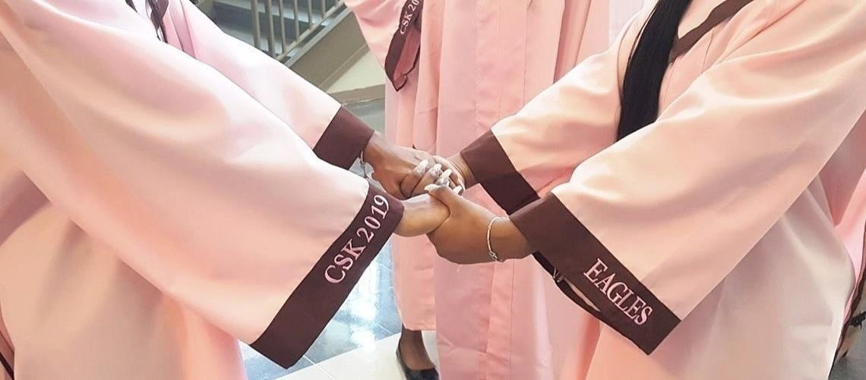  CSKYWLA Student Expectations  - Be in attendance and on time for ALL classes and participate in instructional time according to the schools established bell schedule.  - Be prepared with school supplies to complete ALL learning tasks needed to support standard mastery and submit ALL assignments by the due date communicated.  - Must adhere to CSKYWLA dress code.  - Attend ALL tutorial sessions for additional support and remediation.  - Maintain a spirit of excellence and monitor oneself according to the CSK student pledge and creed.  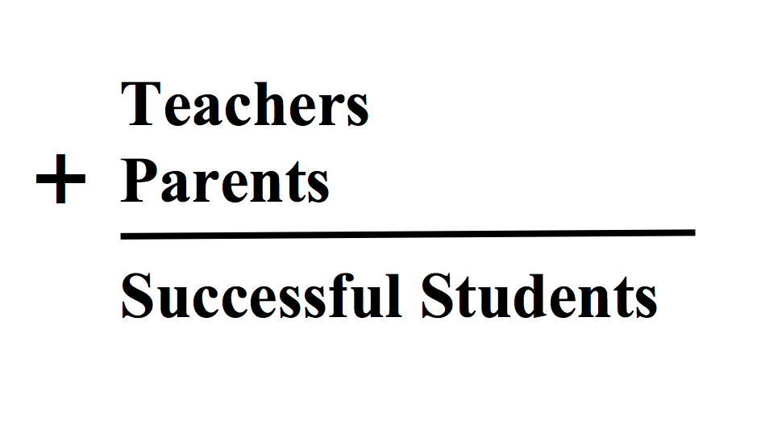  “CSK Embraces APS Five”  - Whole Child  - Curriculum & Instruction  - Data  - Personalized learning  - Signature Programming

